David Liu

CSS 430

HW02

* In Unix, the first process is called init. All the others are descendants of “init”. The init process spawns a sshd process that detects a new secure ssh requested connection (WKPort 22). Upon a new connection, sshd spawns a login process that then loads a shell on it when a user successfully logs into the system. Now, assume that the user types
  + who | grep <uwnetid> | wc –l
  + 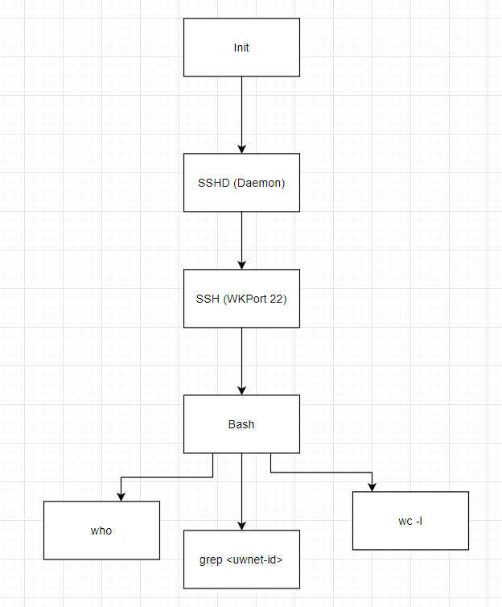
  + Draw a process tree from init to those three commands. Add fork, exec, wait, and pipe system calls between any two processes affecting each other.
  + 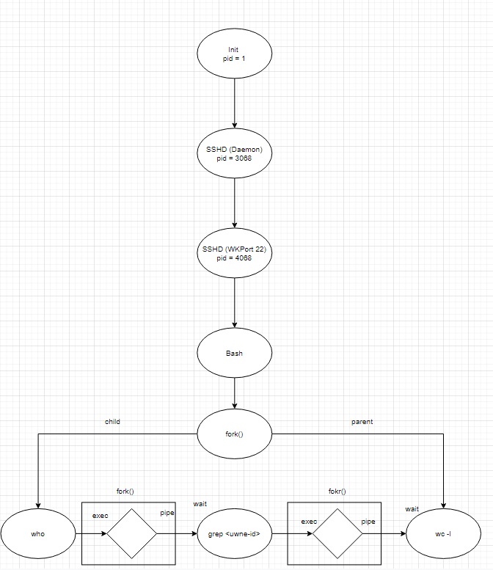
* 3.2
  + Including the initial parent process, how many processes are created by
  + the program shown in Figure 3.31?
    - 8 processes - each process is duped 3 times.
* 3.8
  + Describe the actions taken by a kernel to context-switch between processes.
    - The OS uses a stack pointer of the current process and gives the kernel clock interrupt handler authority over the current process and saves the current state of the registers. The scheduler then chooses the next process to execute and executes it with refreshed registers in the previously interrupted state.
* 3.10
  + Explain the role of the init (or systemd) process on UNIX and Linux systems in regard to process termination.
    - Whenever a process is finished, it turns into a zombie state and waits for the parent process to wait. It remains a zombie as long as the parent process doesn’t finish. When the parent process does finish, init chooses another process. Init can pause a process and start another one if it chooses.
* 3.13
  + Using the program in Figure 3.34 ,identify the values of pid at lines A, B, C, and D. (Assume that the actual pids of the parent and child are 2600 and 2603, respectively.)
    - PID A = 0 - First child process is always 0
    - PID B = 2603 - Child PID given
    - PID C = 2603 - Within child
    - PID D = 2600 - Given parent process